Test Case: tc001_SPX_Dev5_Crear_Requisicion_Spot_Tipo_Cobro_CC
Step 1 - Enter username and password and click to button Enter : Credentials Entered
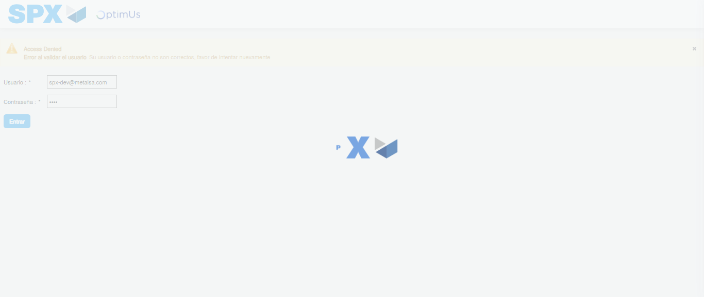Image file-name: QC_Testing-tc001_SPX_Dev5_Crear_Requisicion_Spot_Tipo_Cobro_CC-1783359368010

Step 2 - Select to UEN and Access to Spot Buy Requisitions : UEN Correctly selected and Correct access
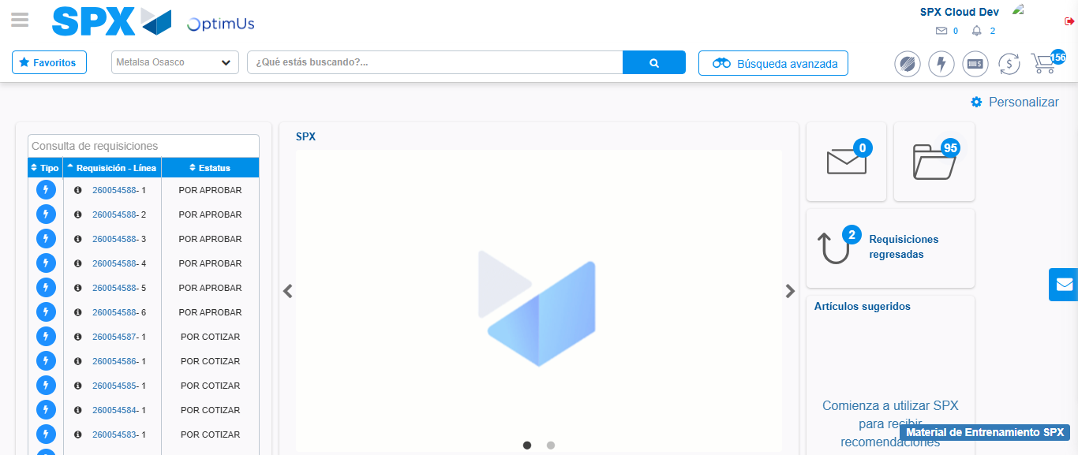Image file-name: QC_Testing-tc001_SPX_Dev5_Crear_Requisicion_Spot_Tipo_Cobro_CC-1783359394533

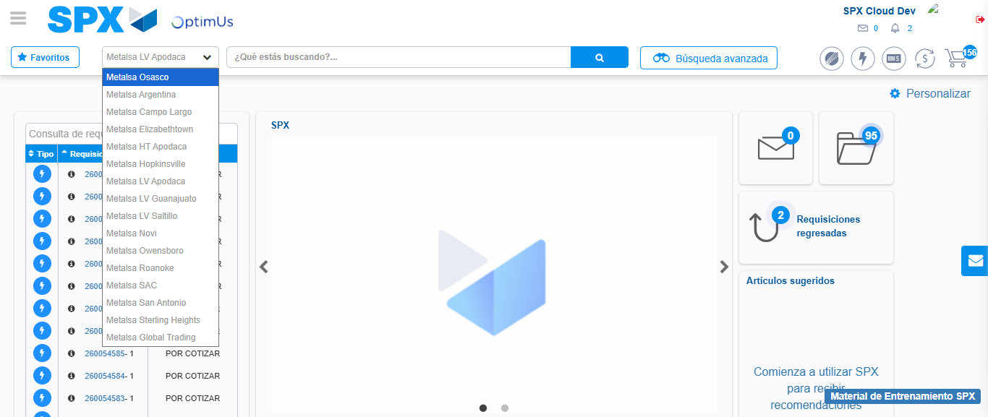Image file-name: QC_Testing-tc001_SPX_Dev5_Crear_Requisicion_Spot_Tipo_Cobro_CC-1783359397263

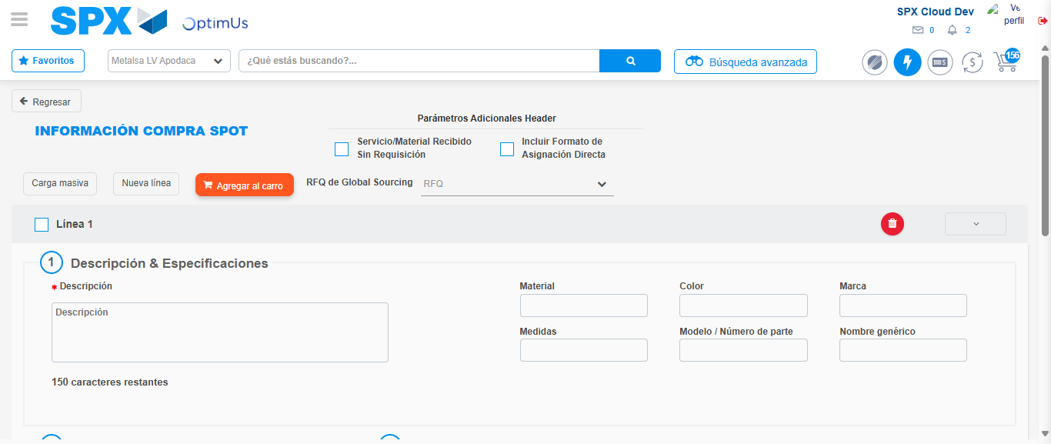Image file-name: QC_Testing-tc001_SPX_Dev5_Crear_Requisicion_Spot_Tipo_Cobro_CC-1783359413844

Step 3 - Data Capture Spot Buy Requisition : Data captured correctly
Image file-name: QC_Testing-tc001_SPX_Dev5_Crear_Requisicion_Spot_Tipo_Cobro_CC-1783359414084

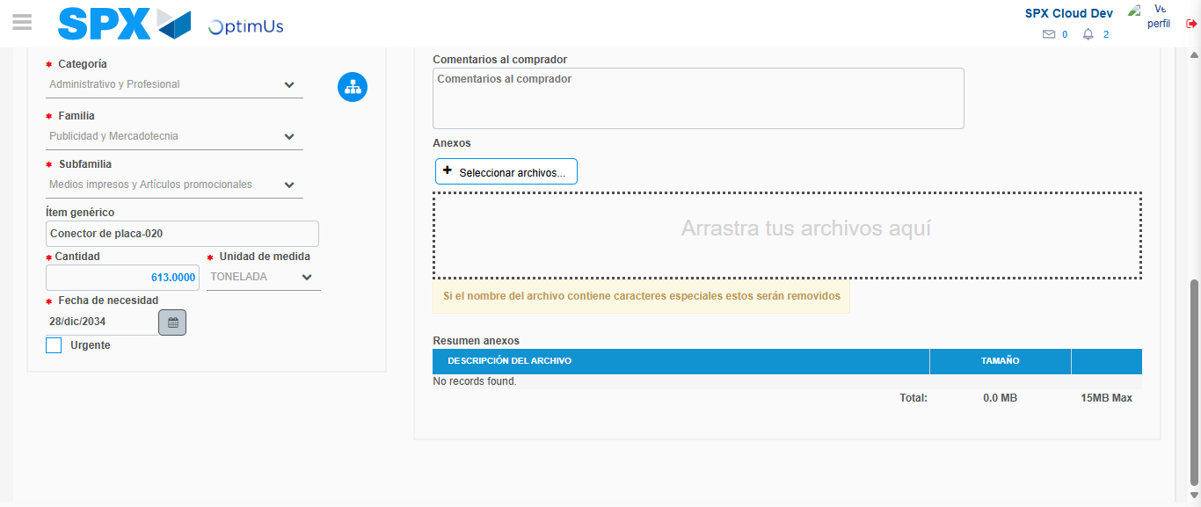Image file-name: QC_Testing-tc001_SPX_Dev5_Crear_Requisicion_Spot_Tipo_Cobro_CC-1783359424600

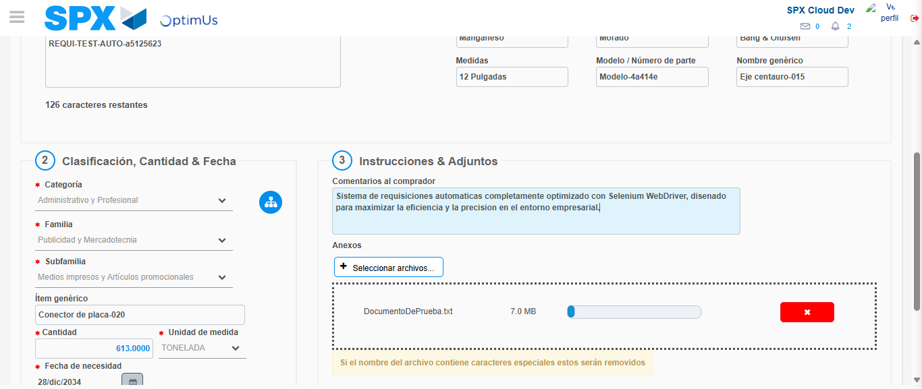Image file-name: QC_Testing-tc001_SPX_Dev5_Crear_Requisicion_Spot_Tipo_Cobro_CC-1783359425330

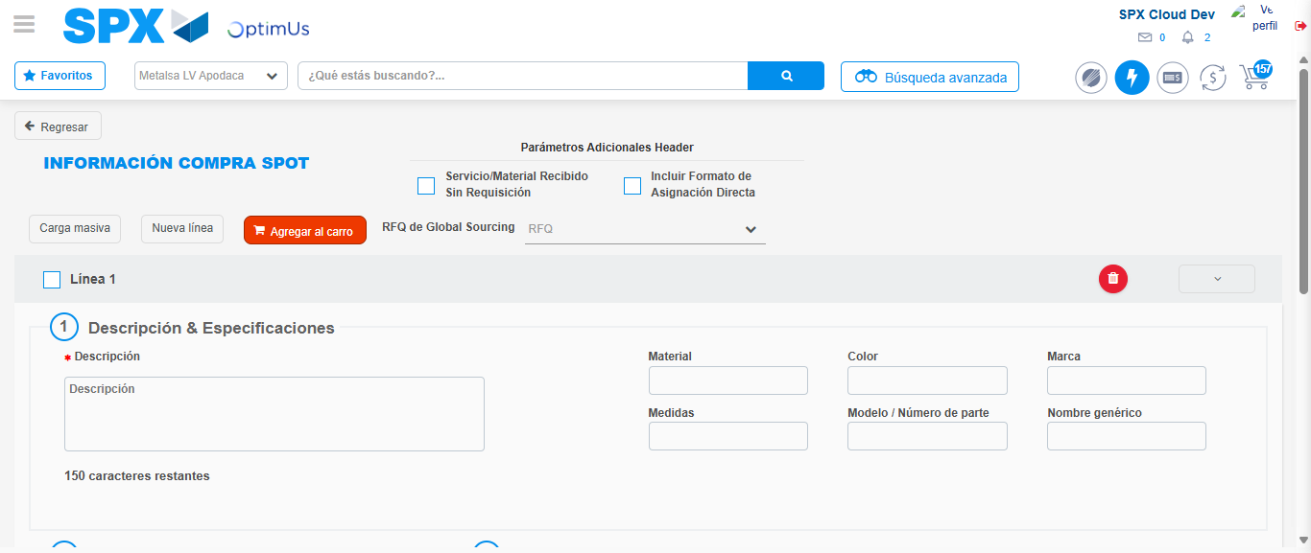Image file-name: QC_Testing-tc001_SPX_Dev5_Crear_Requisicion_Spot_Tipo_Cobro_CC-1783359437845

Step 7 - Return to Main Page SPX : Return to Main Page SPX
Image file-name: QC_Testing-tc001_SPX_Dev5_Crear_Requisicion_Spot_Tipo_Cobro_CC-1783359394533

Image file-name: QC_Testing-tc001_SPX_Dev5_Crear_Requisicion_Spot_Tipo_Cobro_CC-1783359397263

Image file-name: QC_Testing-tc001_SPX_Dev5_Crear_Requisicion_Spot_Tipo_Cobro_CC-1783359413844

Image file-name: QC_Testing-tc001_SPX_Dev5_Crear_Requisicion_Spot_Tipo_Cobro_CC-1783359440151

Image file-name: QC_Testing-tc001_SPX_Dev5_Crear_Requisicion_Spot_Tipo_Cobro_CC-1783359440335

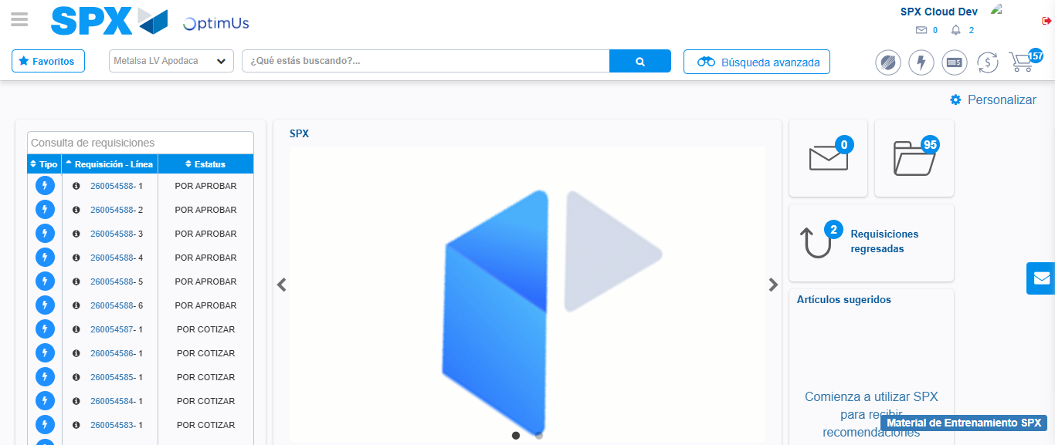Image file-name: QC_Testing-tc001_SPX_Dev5_Crear_Requisicion_Spot_Tipo_Cobro_CC-1783359461329

Step 8 - Log Out : Log Out SPX
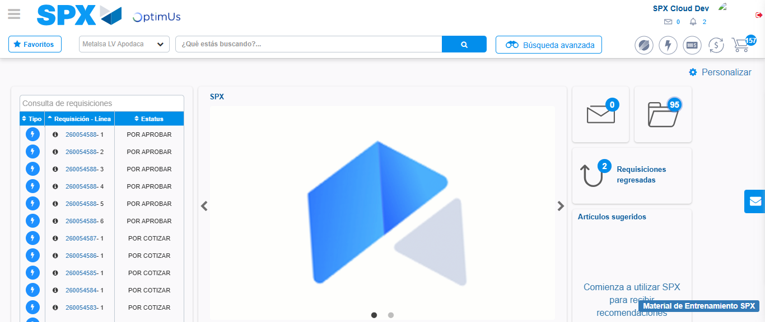Image file-name: QC_Testing-tc001_SPX_Dev5_Crear_Requisicion_Spot_Tipo_Cobro_CC-1783359461648

